Audit of IT Governance Based on COBIT 5 Assessments: A Case Study
Johanes Fernandes Andry
Faculty of Technology and Design, Bunda Mulia University, Jl.Lodan Raya No.2, Jakarta, 14430, Indonesia
E-mail: jandry@bundamulia.ac.id

Abstract— Training Center in Jakarta offers a certification program for the individuals and companies who wish to search for or complement international scale IT certifications. The certification program consists of training certification exam preparation and certification exams. The purpose of this research is to get an overview of the performance of information technology governance in order to determine the extent of the capabilities of information technology governance in the Training Center which is currently running, with a few aspects to consider such as effectiveness, efficiency, functional unit of information technology within an organization. Implementing IT governance, however, is a challenge to organizations. To ensure IT alignment with business goals use standard COBIT. COBIT 5 Framework is a service for auditing IS/IT are the most commonly used to audit information systems in a rapid, accurate, and interactive. The result of this audit training center is business and IT management are aware of the impact of not managing performance and capacity. Performance needs are generally met based on assessments of individual systems and the knowledge of support and project teams. In this paper the method to be used is COBIT 5 is focused on the domain of DSS (Deliver, Service, and Support).

Keyword— Audit, IT Governance, COBIT 5.

Intisari— Training Center di Jakarta menawarkan program sertifikasi bagi individu dan perusahaan yang ingin mencari atau melengkapi sertifikasi skala IT internasional. Program sertifikasi terdiri dari sertifikasi pelatihan persiapan ujian dan sertifikasi ujian. Tujuan dari penelitian ini adalah untuk mendapatkan gambaran tentang kinerja tata kelola teknologi informasi untuk menentukan sejauh mana kemampuan tata kelola teknologi informasi di Training Center yang saat ini berjalan, dengan beberapa aspek yang perlu dipertimbangkan seperti efektivitas, efisiensi , unit fungsional teknologi informasi dalam sebuah organisasi. Penerapan IT Governance, bagaimanapun, adalah sebuah tantangan untuk organisasi. untuk memastikan IT sejalan dengan tujuan bisnis di gunakan standar COBIT. Framework COBIT 5 adalah layanan untuk audit IS / IT yang paling sering digunakan untuk mengaudit sistem informasi secara cepat, akurat, dan interaktif. Hasil audit ini menyatakan bahwa bisnis dan manajemen TI menyadari dampak dari tidak mengelola kinerja dan kapasitas. kebutuhan kinerja umumnya dipenuhi berdasarkan penilaian sistem individu dan dukungan pengetahuan dan team proyek . Dalam paper ini metode yang akan digunakan adalah COBIT 5 difokuskan pada domain DSS (Deliver, Layanan, dan Dukungan).

Kata Kunci— Audit, IT Governance, COBIT 5.
- INTRODUCTION
According to Fadzil et al (2005), the technology revolution in accounting and auditing began in the summer of 1954 with the first operational business computer [1], [2]. Nowadays, most of the management agrees on necessity of considering IT as an “organizational strategic player”. As organization’s strategy changes over time, IT has to change too [3].
IT governance is a process by which the objectives of the entity that give impact on Information technology are agreed, directed, and controlled [4], [5]. The primary focus of IT governance is on the responsibility of the board and executive management to control formulation and the implementation of IT strategy, to ensure the alignment of IT and business, to identify metrics for measuring business value of IT and to manage IT risks in an effective way [6]. Companies commonly use governance control frameworks to establish and assess control processes. The use of frameworks for the construction and evaluation of IT controls results in more reliable and comprehensive control systems (Tuttle and Vandervelde, 2007). This study uses the COBIT control framework to evaluate the performance of IT control governance in freight forwarding companies [7]. IT governance is a concept that has suddenly emerged and become an important issue in the information technology field. Precisely when this new challenge began surfacing is unknown, but it is now a discussion issue within most organizations [8]. Information technology (IT) governance is a relatively new subset of corporate governance that focuses on the management and assessment of strategic IT resources. Key objectives of IT governance are to reduce risk and ensure that investments in IT resources add value to the corporation [9]. IT Governance (ITG) is the vital and unique solution to ensure positive returns [10], [11].
The purpose of this research is to get an overview of the performance of information technology governance in order to determine the extent of the capabilities of information technology governance in the Training Center which is currently running, with a few aspects to consider such as: effectiveness, efficiency, functional unit of information technology within an organization, the data integrity, safeguarding assets, reliability, confidentiality, availability, and security [23]. The benefits of this research was to determine the level of process capability model IT in the Training Center using COBIT 5, focused to domain DSS (Deliver Service and Support).
- TEORITICAL BACKGROUND
  - Audit
Business organizations undergo different types of audits for different purposes. The most common of these are external (financial) audits, internal audits, and fraud audits. An IT audit focuses on the computer-based aspects of an organization’s information system; and modern systems employ significant levels of technology [9], [24]. Audit is playing an important role in developing and enhancing the global economy and business firms [12]. Ron Weber (1999) argued that Information systems auditing is the process of collecting and evaluating evidence to determine if a computer system safeguards asses, maintain data integrity, allow organizational goals to be achieved effectively, and use resources efficiently [13].
  - IT Governance
Information Technology Governance Institute (ITGI) (2003) defined IT Governance as "it is the responsibility of the board of directors and executive management. It is an integral part of enterprise governance and consists of the leadership and organizational structures and processes that ensure the organization's IT sustains and extends the organization's strategies and objectives"[14]. IT governance is the structure of relationships, processes and mechanisms used to develop, direct and control IT strategy and resources so as to best achieve the goals and objectives of an enterprise. It is a set of processes aimed at adding value to an organization while balancing the risk and return aspects associated with IT investments [15].
Gartner defines IT governance as the set of processes that ensure the effective and efficient use of IT enabling an organization to achieve its goals. IT is an integral part of enterprise governance and consists of the leadership and organizational structures and processes that ensure the organization’s IT sustains and extends the organization’s strategies and objectives. Doughty defines IT governance to be a framework that supports the effective and efficient management of information resources (e.g. people, funding and information) to facilitate the achievement of corporate objectives. The focus is on the measurement and management of IT performance to ensure that the risks and costs associated with IT are appropriately controlled [16]. Gartner states that IT governance addresses two major topics: IT demand governance (“doing the right thing”) and IT supply-side governance (“doing things right”). The focus of this paper is on COBIT 5 framework and how it covers both the governance and management of IT [17].
  - COBIT 5
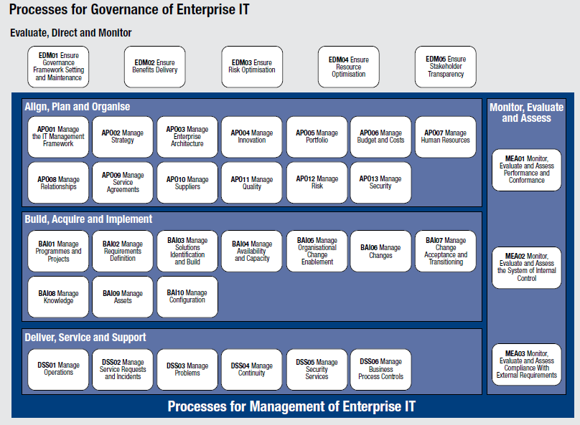

Figure 1. COBIT 5 Process Reference Model
In 2005 ISACA introduced a new, fourth version of COBIT with a clear focus on IT governance [18]. A further version of this framework is COBIT 4.1, released in 2007, accepting the generally used frameworks such as “IT Infrastructure Library (ITIL)”, “ISO 27000 series” and “Capability Maturity Model® Integration (CMMI)” [19]. The current version of the framework, COBIT 5, was released in 2012. The COBIT 5 process reference model is the successor of the COBIT 4.1 process model, with the Risk IT and Val IT process models integrated as well. Figure 1. COBIT 5 Process Reference Model, shows the complete set of 37 governance and management processes within COBIT 5.
According to [20], [22] the six levels of the COBIT 5 Process Capability Model are:
TABEL I.
COBIT 5 Process Capability Model
Level | Description
Level 0: Incomplete process. | The process is not placed or it cannot reach its objective. At this level the process has no objective to achieve. For this reason this level has no attribute.
Level 1: Performed process. | The process is in place and achieves its own purpose. This level has only “Process Performance” as process attribute.
Level 2: Managed process. | The process is implemented following a series of activities such as planning, monitoring and adjusting activities. The outcomes are established, controlled and maintained. This level has “Performance Management” and “Work Product Management” as process attributes.
Level 3: Established process. | The previous level is now implemented following a defined process that allows the achievement of the process outcomes. This level has “Process Definition” and “Process Deployment” as process attributes.
Level 4: Predictable process. | This level implements processes within a defined boundary that allows the achievement of the processes outcomes. This level has “Process Management” and “Process Control” as process attributes.
Level 5: Optimising process. | This level implements processes in the way that makes it possible to achieve relevant, current and projected business goals. This level has “Process Innovation” and “Process Optimisation” as process attributes.

In COBIT 5 to achieve a given level of capability, the previous level has to be completely achieved [20].
- RESEARCH METHOD
This paper is the result of a practical research. The type of data gathering is questionnaire [21]. Field observations, this research are a survey approach. The analytical tool used in this study is the standard procedure COBIT issued by ISACA (Information systems Audit and Control Association), the data can be obtained by various methods, namely: The questionnaire, which is by distributing questionnaires to every part belonging to management, the number of scattered management is 5. In addition, a questionnaire distributed to the user a number of 45 respondents, so the overall total respondents obtained is 50.
Reporting, after questionnaires were distributed, it will get the data to be processed to be calculated based on the maturity level calculation. For further made several steps in reporting that the results of the audit contains the findings of the present (current level) and hope in the future (expected level), performed gap analysis to analyze the interpretation of the current level and expected and recommendation lists corrective actions to overcome gap undertaken to achieve the improvements made to the institution. Figure 3 to show Step by Step Index Level Proses Capability Model [21].

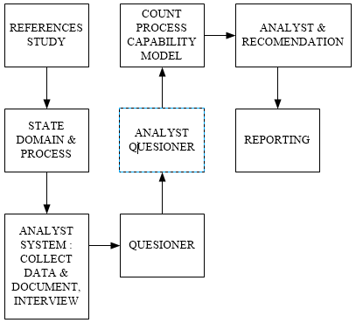

Figure 2. Step by Step Index Level Proses Capability Model
- RESULT AND ANALYSIS
Training Center (here in after call as TC) is a business company has been running since 2012 has had experience delivering information technology solutions and professional services for many companies in Indonesia, from small medium business until enterprises. The ability and success of the company in providing training not only supported by a solid team which consists of professional trainers who are advanced in their field but also of factors of cooperation from a client that was maintained well up to now, both for training public and in-house training. This chapter, the author will analyze general control with the COBIT framework approach. Authors will analyze more to the environment that occur within the IT department TC, from employees, equipment, physical security, regulations, etc [23], [24].

A. DSS01 Manage Operations
In this stage the author will analyze deliver IT operational service outcomes as planned, with process description is co-ordinate and executes the activities and operational procedures required to deliver internal and outsourced IT services, including the execution of pre-defined standard operating procedures and the required monitoring activities. Expected process capability model of DSS01 manage operations is level 4, predictable process [22]. In more detail are sub domains, see Table 2. Process Capability Domain DSS01 Manage Operations.
Concluded the average DSS01 being at the level 2.8, Managed Process.

Table 2. Process Capability Domain DSS01 Manage Operations
No. | Sub Domain | Current | Expected
DSS01.01 | Perform operational procedures | 3 | 4
DSS01.02 | Manage outsourced IT services | 3 | 4
DSS01.03 | Monitor IT infrastructure | 2 | 4
DSS01.04 | Manage the environment | 3 | 4
DSS01.05 | Manage facilities | 3 | 4

B. DSS02 Manage service requests and incidents.
In this stage the author will analyze achieve increased productivity and minimize disruptions through quick resolution of user queries and incidents, with process description is provide timely and effective response to user requests and resolution of all types of incidents. Restore normal service; record and fulfill user requests; and record, investigate, diagnose, escalate and resolve incidents. Expected process capability model of DSS02 manage service requests and incidents is Level 4, predictable process. In more detail are sub domains, see Table 3. Process Capability Domain DSS02 Manage Service Request and Incidents.
Concluded the average DSS02 being at the level 2.3, Managed Process.

Table 3. Process Capability Domain DSS02 Manage service requests and incidents
No. | Sub Domain | Current | Expected
DSS02.01 | Define incident and service request classification schemes. | 2 | 4
DSS02.02 | Record, classify and prioritize requests and incidents. | 2 | 4
DSS02.03 | Verify, approve and fulfill service requests. | 2 | 4
DSS02.04 | Investigate, diagnose and allocate incidents. | 3 | 4
DSS02.05 | Resolve and recover from incidents. | 2 | 4
DSS02.06 | Close service requests and incidents. | 3 | 4
DSS02.07 | Track status and produce reports. | 2 | 4

C. DSS03 Manage problems.
In this stage the author will analyze Increase availability, improve service levels, reduce costs, and improve customer convenience and satisfaction by reducing the number of operational problems, with process description is identify and classify problems and their root causes and provide timely resolution to prevent recurring incidents. Provide recommendations for improvements. Expected process capability model of DSS03 manage problems is level 4, predictable process. In more detail are sub domains, see Table 4. Process Capability Domain DSS03 Manage Problems.
Concluded the average DSS03 being at the level 2.4, Managed Process.

Table 4. Process Capability Domain DSS03 Manage Problems
No. | Sub Domain | Current | Expected
DSS03.01 | Identify and classify problems. | 2 | 4
DSS03.02 | Investigate and diagnose problems. | 2 | 4
DSS03.03 | Raise known errors. | 3 | 4
DSS03.04 | Resolve and close problems. | 3 | 4
DSS03.05 | Perform proactive problem management. | 2 | 4

D. DSS04Manage continuity.
In this stage the author will analyze continue critical business operations and maintain availability of information at a level acceptable to the enterprise in the event of a significant disruption, with process description is establish and maintain a plan to enable the business and IT to respond to incidents and disruptions in order to continue operation of critical business processes and required IT services and maintain availability of information at a level acceptable to the enterprise. Expected process capability model of DSS04 Manage continuity is level 4, predictable process. In more detail are sub domains, see Table 5. Process Capability Domain DSS04 Manage Continuity.
Concluded the average DSS04 being at the level 2.5, Managed Process.

Table 5. Process Capability Domain DSS04 Manage continuity
No. | Sub Domain | Current | Expected
DSS04.01 | Define the business continuity policy, objectives and scope. | 3 | 4
DSS04.02 | Maintain a continuity strategy. | 3 | 4
DSS04.03 | Develop and implement a business continuity response. | 3 | 4
DSS04.04 | Exercise, test and review the BCP. | 2 | 4
DSS04.05 | Review, maintain and improve the continuity plan. | 2 | 4
DSS04.06 | Conduct continuity plan training. | 2 | 4
DSS04.07 | Manage backup arrangements | 3 | 4
DSS04.08 | Conduct post-resumption review. | 2 | 4

E. DSS05 Manage security services.
In this stage the author will analyze minimize the business impact of operational information security vulnerabilities and incidents, with process description is protect enterprise information to maintain the level of information security risk acceptable to the enterprise in accordance with the security policy. Establish and maintain information security roles and access privileges and perform security monitoring. Expected process capability model of DSS05 manage security services is level 4, Predictable process. In more detail are sub domains, see Table 6. Process Capability Domain DSS05 Manage Security Services.
Concluded the average DSS05 being at the level 2.7, Managed Process.

Table 6. Process Capability Domain DSS04 Manage security services
No. | Sub Domain | Current | Expected
DSS05.01 | Protect against malware. | 3 | 4
DSS05.02 | Manage network and connectivity security. | 3 | 4
DSS05.03 | Manage endpoint security. | 3 | 4
DSS05.04 | Manage user identity and logical access. | 3 | 4
DSS05.05 | Manage physical access to IT assets. | 3 | 4
DSS05.06 | Manage sensitive documents and output devices. | 2 | 4
DSS05.07 | Monitor the infrastructure for security-related events. | 2 | 4

F. DSS06 Manage business process controls.
In this stage the author will analyze maintain information integrity and the security of information assets handled within business processes in the enterprise or outsourced, with process description is define and maintain appropriate business process controls to ensure that information related to and processed by in-house or outsourced business processes satisfies all relevant information control requirements. Identify the relevant information control requirements and manage and operate adequate controls to ensure that information and information processing satisfy these requirements. Expected process capability model of DSS06 manage business process controls is level 4, Predictable process. In more detail are sub domains, see Table 7. Process Capability Domain DSS05 Manage Business Process Controls.
Concluded the average DSS05 being at the level 2.2, Managed Process.

Table 7. Process Capability Domain DSS06 Manage business process controls.
No. | Sub Domain | Current | Expected
DSS06.01 | Align control activities embedded in business processes with enterprise objectives. | 2 | 4
DSS06.02 | Control the processing of information. | 2 | 4
DSS06.03 | Manage roles, responsibilities, access privileges and levels of authority. | 2 | 4
DSS06.04 | Manage errors and exceptions. | 3 | 4
DSS06.05 | Ensure traceability of information events and accountabilities. | 2 | 4
DSS06.06 | Secure information assets. | 2 | 4

Figure 3 and Table 8 to show Index Level Process Capability domain Deliver Service and Support.

Table 8. Index Level Process Capability domain Deliver Service and Support.
Average Domain | Current | Expected | Optimized
DSS01 | 2.8 | 4 | 5
DSS02 | 2.3 | 4 | 5
DSS03 | 2.4 | 4 | 5
DSS04 | 2.5 | 4 | 5
DSS05 | 2.7 | 4 | 5
DSS06 | 2.2 | 4 | 5

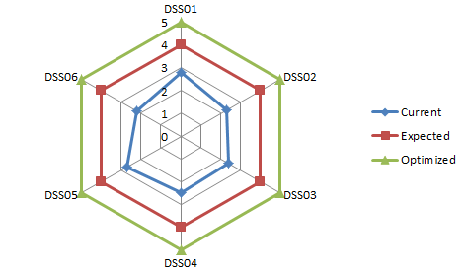
Figure 3. Index Level Process Capability domain Deliver Service and Support

- CONCLUSION
This study provides an overview on IT governance, the necessity of IT governance in training center, COBIT framework and the concepts related to the framework implementation. In order to reach effective IT governance, the business and IT should be understand each other. The result of this audit training center is business and IT management are aware of the impact of not managing performance and capacity. Performance needs are generally met based on assessments of individual systems and the knowledge of support and project teams. Availability problems are likely to occur in an unexpected and random fashion and take considerable time to diagnose and correct.

References

- F.H. Fadzil, H. Haron and M. Jantan, "Internal auditing practices and internal control System,” Managerial Auditing Journal, vol. 20, no 8, pp. 844-866, 2005.
- J. O. Polo and D. Oima, “Effect of Computerised Accounting Systems on Audit Risk Management in Public Enterprises: A Case of Kisumu County, Kenya,” International Journal of Education and Research, vol. 1, no. 5, pp. 1-10, 2013.
- A. Latif and N. Hanifi, “Analyzing IT Function Using COBIT 4.1 A Case Study of Malaysian Private University,” Journal of Economics, Business and Management, vol. 1, no. 4, pp. 406-408, 2013.
- W. V. Grembergen and S. D. Haes, “Enterprise Governance of Information Technology: Achieving Strategic Alignment and Value,” Springer, New York, 2009.
- R. A. Khther and M. Othman, “Cobit Framework as a Guideline of Effective IT Governance in Higher Education : A Review,” International Journal of Information Technology Convergence and Services, vol. 3, no. 1, pp. 21-29, 2013.
- D. Lacković, “Model for IT Governance Assessment in Banks Based on Integration of Control Function,” International Conference Active Citizenship by Management, Knowledge Management & Innovation, pp. 439-444, 2013.
- N. Rezaei, “The Evaluation of Implementing IT Governance Controls,” Journal of Applied Business and Finance Researches, vol. 2, Issue 3, pp. 82-89, 2013.
- S. D. Haes and W. V. Grembergen, “IT Governance and Its Mechanisms,” Information Systems Audit and Control Association. Available : www.isaca.org, 2004.
- J. A. Hall, “Information Technology Auditing and Assurance,” Third Edition, South-Western, Cengage Learning, 2011.
- D. D. Jacobson, “Revisiting IT Governance in the Light of Institutional Theory, In System Sciences,” 42nd Hawaii International Conference on IEEE, pp. 1-9, 2009.
- C. Meriyem, S. Adil and M. Hicham, “IT Governance Ontology Building Process : Example of developing Audit Ontology,” International Journal of Computer Techniques, vol. 2, Issue 1, pp. 134-141, 2015.
- H. A. Khaddash, R. A. Nawas and A. Ramadan,” Factors affecting the quality of Auditing: The Case of Jordanian Commercial Banks,” International Journal of Business and Social Science, vol. 4, no. 11, pp. 206-222, 2013.
- E. Maria and E. Haryani, “Audit Model Development of Academic Information System : Case Study on Academic Information System of Satya Wacana,” International Refereed Research Journal, vol. II, Issue 2, pp. 12-24, 2011.
- I. M. A. Zwyalif, “IT Governance and its Impact on the Usefulness of Accounting Information Reported in Financial Statements,” International Journal of Business and Social Science, vol. 4, no. 2, pp. 83-94, 2013.
- T. Sethibe, J. Campbell and C. McDonald, “IT Governance in Public and Private Sector Organisations: Examining the Differences and Defining Future Research Directions,” 18th Australasian Conference on Information Systems, pp. 833-843, 2007.
- K. Doughty, “IT Governance: Pass or Fail?,” Information Systems Control Journal 3, 2005.
- S. Khanyile and H. Abdullah, “COBIT 5: an evolutionary framework and only framework to address the governance and management of enterprise IT,” UNISA.
- ITGI: COBIT Mapping: Mapping ISO/IEC 17799:2005 with COBIT 4.0, p. 6, 2006.
- ITGI: COBIT 4.1 Excerpt, p. 9, 2007.
- A. Pasquini, “COBIT 5 and the Process Capability Model. Improvements Provided for IT Governance Process,” Proceedings of FIKUSZ ’13 Symposium for Young Researchers, Published by Óbuda University, pp. 67-76, 2013.
- A. Amid and S. Moradi, ”A Hybrid Evaluation Framework of CMM and COBIT for Improving the Software Development Quality,” Journal of Software Engineering and Applications, pp. 280-288, 2013.
- ISACA: COBIT Five: A Business Framework for the Governance and Management of Enterprise IT, 2012.
- J. F. Andry, “Audit Tata Kelola TI Menggunakan Kerangka Kerja Cobit Pada Domain DS dan ME di Perusahaan Kreavi Informatika Solusindo,” Seminar Nasional Teknologi Informasi dan Komunikasi, pp. 287-294, 2016.
- J. F. Andry, “Audit Sistem Informasi Sumber Daya Manusia Pada Training Center Di Jakarta Menggunakan Framework Cobit 4.1,” Jurnal Ilmiah FIFO, vol. VIII, no.1, pp. 28-34, 2016.

